Milestone Four: Enhancement Three: Databases
The artifact I selected for the databases category is my Travlr full stack web application. This artifact was developed in CS 465 using Angular, Express, MongoDB, and JWT authentication. I chose this artifact because it already includes database integration and can be enhanced further by expanding the database design and functionality
I included this artifact because it shows more than just a basic front-end display. It demonstrates that I can work across the full stack by connecting the user interface, application logic, authentication, API routes, and database design into one working feature. The strongest parts of this artifact are the new booking schema, the API endpoint for creating bookings, the validation logic, the JWT-based user connection, and the public booking workflow. These pieces show my ability to design data relationships, build secure functionality, and improve an existing application in a meaningful way.
This artifact was improved by turning Travlr from a read-only trip site into a more complete travel application. I added a new bookings collection in MongoDB, linked each booking to both a trip and a user, created routes and controllers for booking and trip lookup, and built login, registration, and booking pages on the public site. I also added client-side logic for token handling, redirects, form submission, and confirmation messaging. These changes made the application more interactive, more realistic, and stronger from a database design perspective.
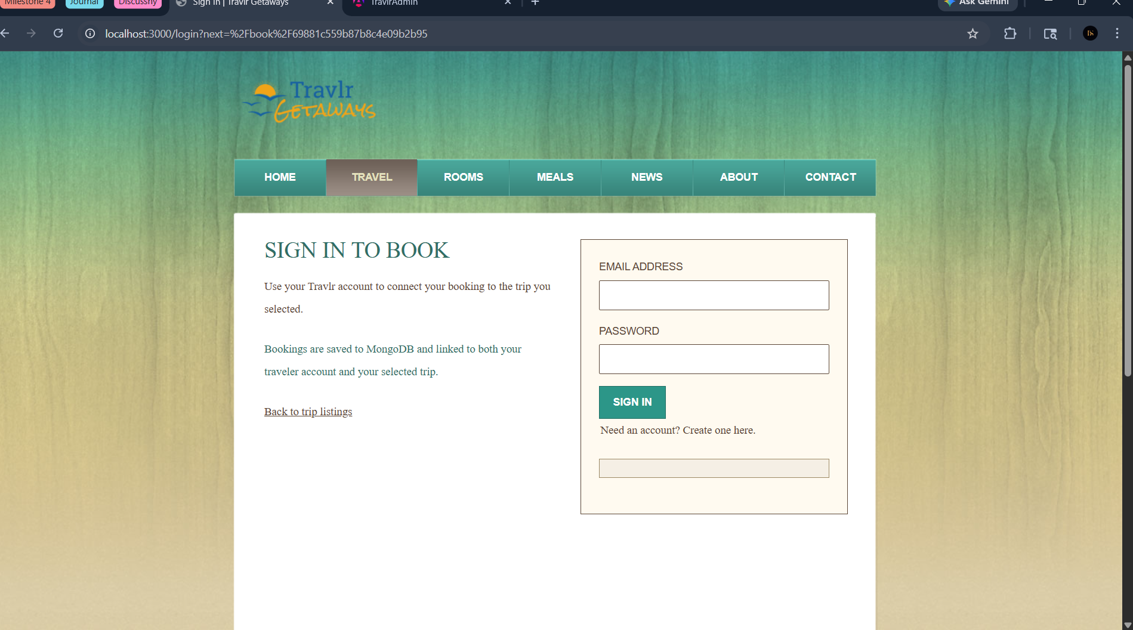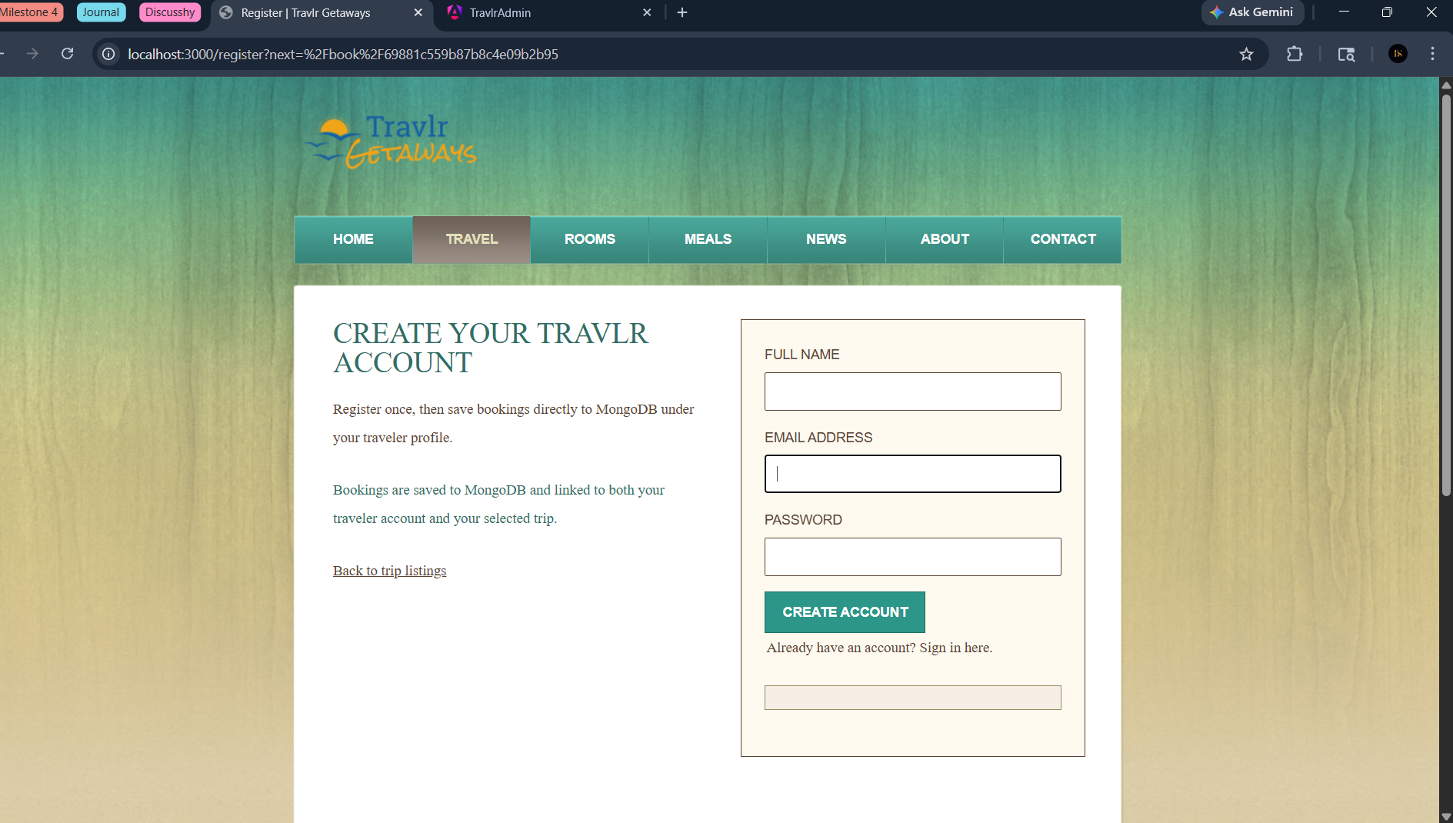
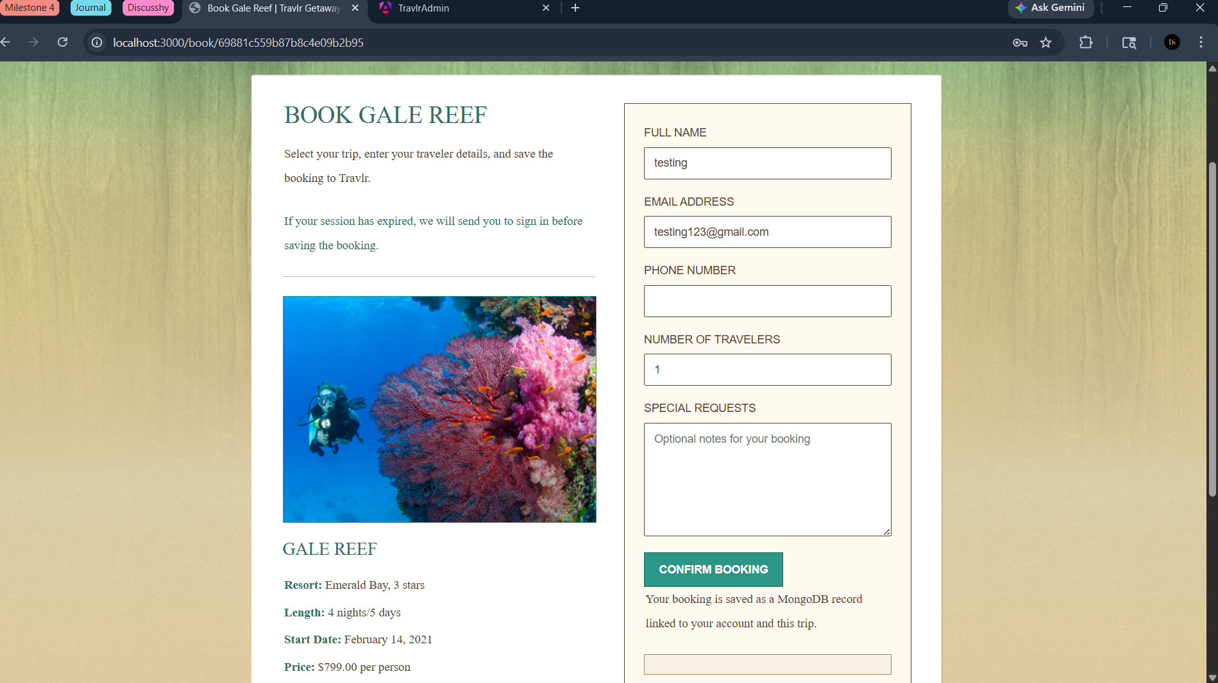

Yes, this enhancement helped me meet the outcomes I planned to address in Module One. In particular, it reflects my ability to design and evaluate a computing solution, use current tools and techniques to implement that solution, and apply a security mindset through authentication and protected API access. At this point, I do not see major changes needed in my outcome-coverage plan. If anything, this artifact now gives me even stronger evidence for database integration, secure development, and full-stack problem solving than I originally expected.
Enhancing this artifact taught me that even a focused feature can affect every layer of an application. Adding bookings was not just about creating a form. It required thinking about data structure, validation, API design, authentication, database relationships, and the user experience. I learned how important it is to keep the front end and back end aligned so that the feature works smoothly from the user’s first click all the way to saving data in MongoDB.
One of the biggest challenges was making sure the booking process was both secure and user-friendly. I had to connect bookings to authenticated users, validate input correctly, and make sure the application handled redirects and confirmation messages in a clear way. Another challenge was preserving the existing trip functionality while extending the system without breaking it. Overall, this enhancement helped me better understand how thoughtful software improvements can make an application more complete, more secure, and more valuable to the user.

